Practical-6

Implement below operations of singly linked list.

(a) Insert a node at front

(b) Delete a node at last

(c) Delete all nodes of linked list

Note: Display content of linked list after each operation.

Program:

#include <iostream>

using namespace std;

struct node

{

int info;

struct node *link;

};

struct node *FIRST = NULL;

struct node *create(int n)

{

struct node *temp;

temp = (struct node *)malloc(sizeof(struct node));

temp->info = n;

temp->link = NULL;

return temp;

}

struct node *insert(int n)

{

struct node *temp1 = create(n);

if (FIRST == NULL)

{

FIRST = temp1;

}

else

{

temp1->link = FIRST;

FIRST = temp1;

}

return FIRST;

}

struct node *Delete()

{

if (FIRST->link == NULL)

{

free(FIRST);

FIRST = NULL;

}

else

{

struct node *trav = FIRST;

struct node *prev;

while (trav->link != NULL)

{

prev = trav;

trav = trav->link;

}

prev->link = NULL;

free(trav);

cout << "Your last node is deleted " << endl;

}

}

void display(struct node *fist)

{

struct node *trav = fist;

while (trav != NULL)

{

cout << trav->info << " ";

trav = trav->link;

}

}

struct node *InsertAtEnd(int d)

{

struct node *temp = create(d);

struct node *tre = FIRST;

while (tre->link != NULL)

{

tre = tre->link;

}

tre->link = temp;

}

struct node *DeleteFirst()

{

struct node *temp = FIRST->link;

free(FIRST);

FIRST = temp;

}

int main()

{

int a, f, d;

do

{

cout << "\nEnter your choice:" << endl;

cout << "1 for Insertion" << endl;

cout << "2 for Delete" << endl;

cout << "3 for display" << endl;

cout << "4 for Insertion at end" << endl;

cout << "5 for Deletion at start " << endl;

cout << "Enter Your Choice: ";

cin >> a;

switch (a)

{

case 1:

cout << "Enter your number: ";

cin >> f;

FIRST = insert(f);

break;

case 2:

Delete();

break;

case 3:

display(FIRST);

break;

case 4:

cout << "Enter your number: ";

cin >> d;

InsertAtEnd(d);

break;

case 5:

DeleteFirst();

}

cout<<endl;

cout<<"This program is prepared by 22CE099 Sneh_patel"<<endl;

} while (a != 0);

return 0;

} OUTPUT:

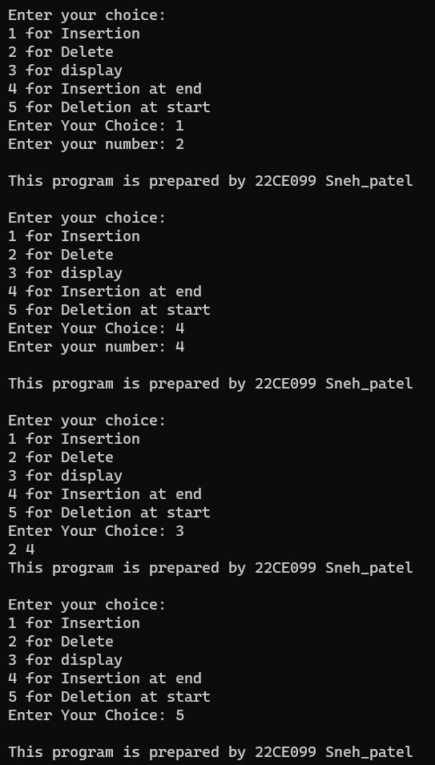

_______________ ________________ __________

Student Signature Faculty Signature Marks